BIT 4107 – Mobile Application Development
ENHANCED PROFESSIONAL STUDENT LOGBOOK
Student Name: Haron Mutai
Admission Number: BIT/2024/73474
School/Faculty: Computing& Informatics
Programme: Information Technology
Academic Year: 2026
Semester: Two
Lecturer: Michael Nyoro
Phone Number: 0758345174

Instructions
This logbook is used to document weekly learning activities, practical exercises, skills acquired, challenges encountered, solutions applied, and reflections. Students should complete all sections every week.
Each week to follow remarks in week 1 section.

Autogenerated Table of content

Week 1: Introduction to Mobile Application Development

Practical Activities Undertaken
- Installed Android Studio.
- Installed Flutter SDK and Dart SDK.
- Configured Android Studio with Flutter and Dart plugins.
- Set up Android Emulator.
- Created the StarShare project.
- Created a GitHub repository for project version control.
- Verified Flutter installation and environment configuration.
- figure1: Installation and setting up of android studio.
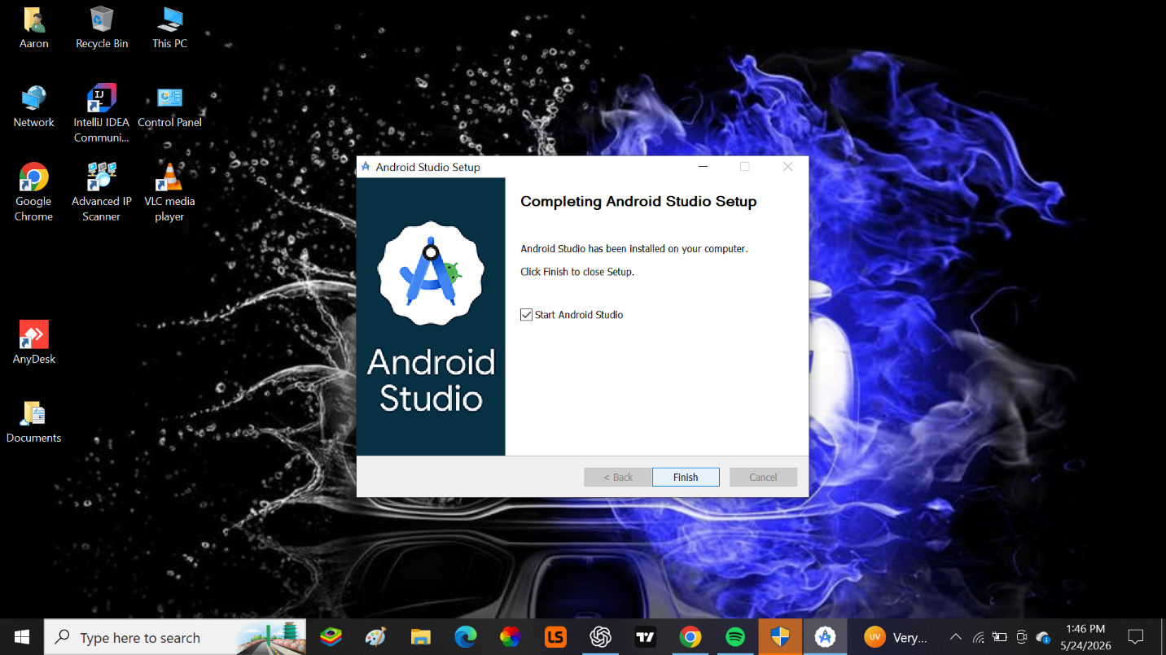
Figure2:Configured Android SDK and Emulator and Verified development environment.
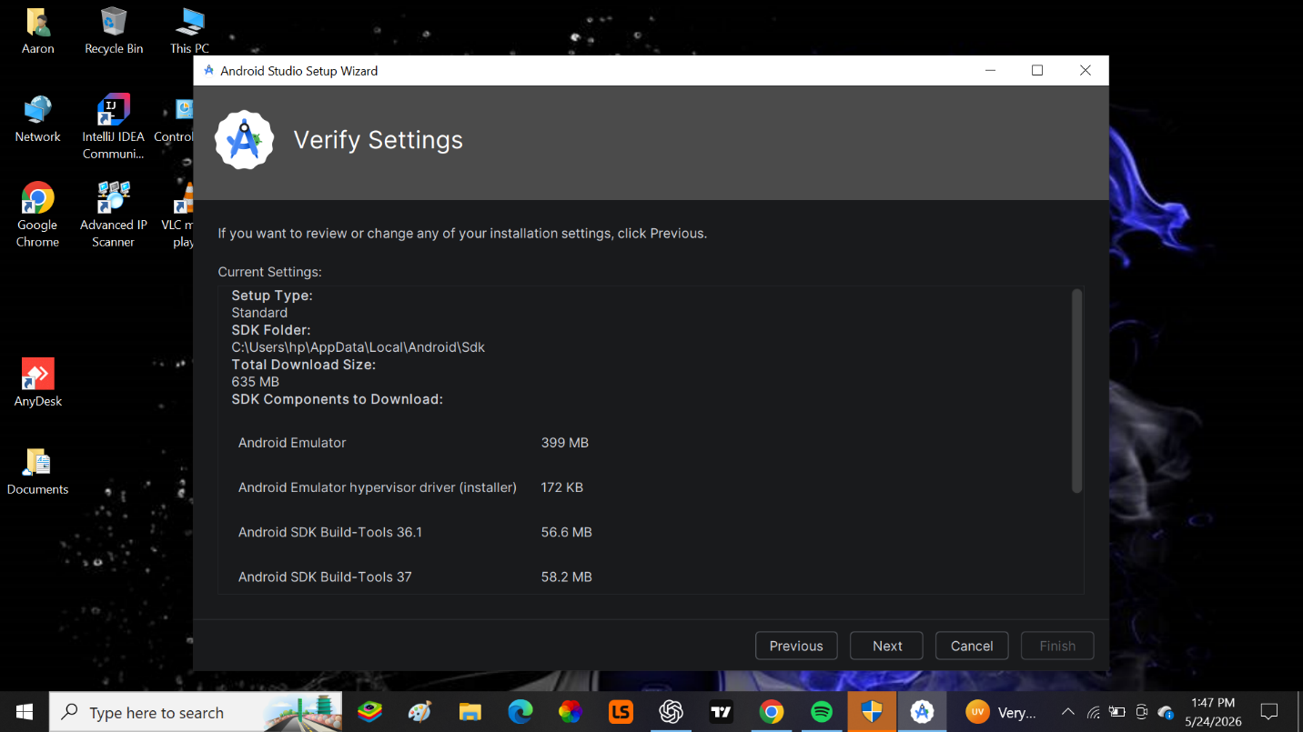
Figure3: Created a new flutter project.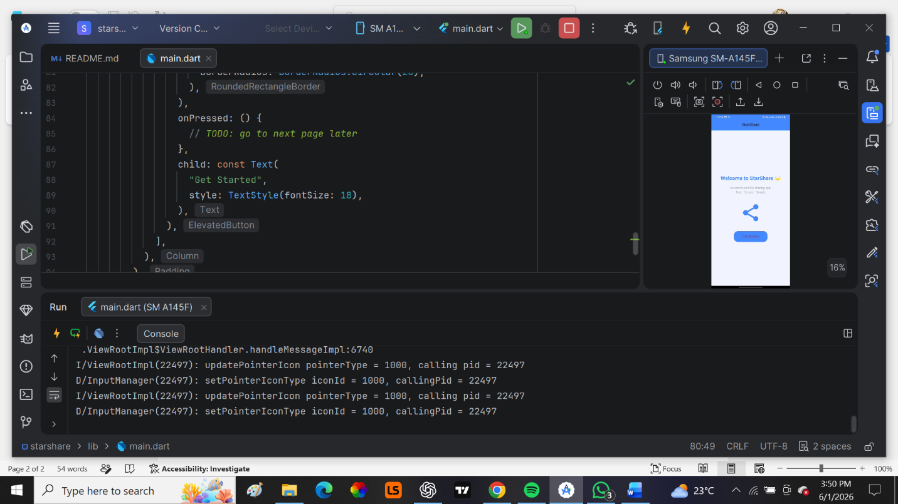
- Figure4: Modified the application title, changed the background colour and adjusted the font size of the application text.

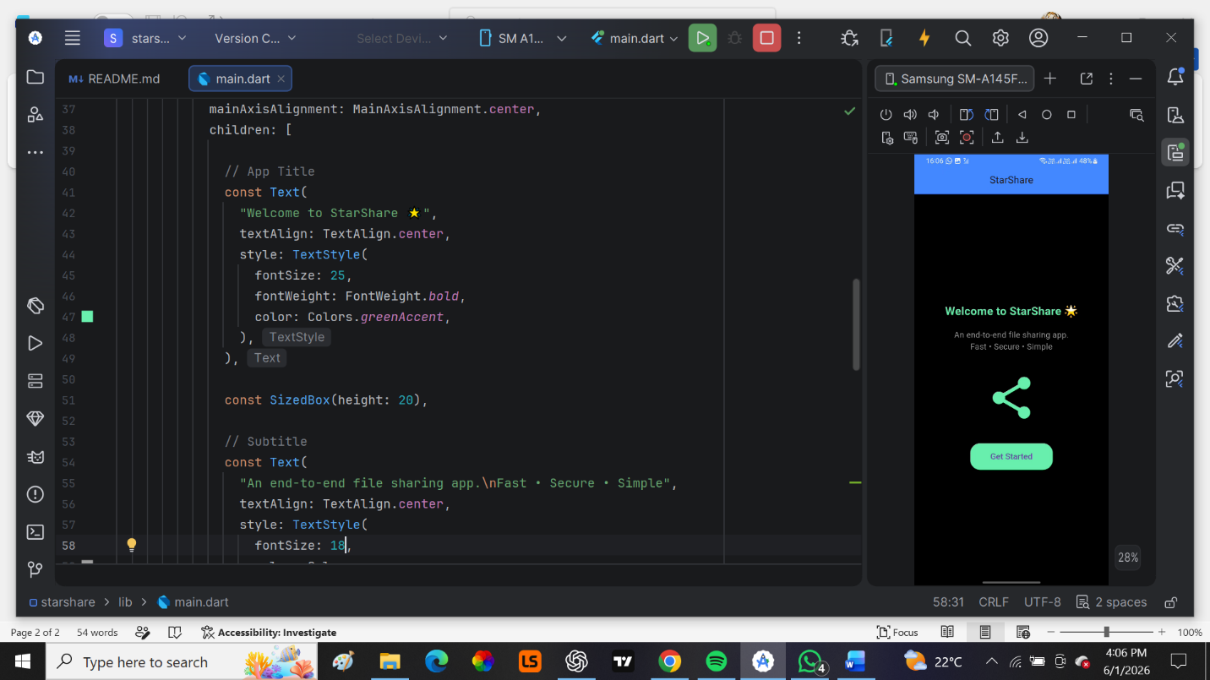

Tools/Software Used
- Android Studio
- Flutter SDK
- Android Emulator
- Phone
- Dart SDK
- Figma

Personal Reflection
I Successfully installed and configured the development environment for the StarShare project. I gained practical experience setting up Flutter, Android Studio, and GitHub, which established a solid foundation for the development process.

Week 2: Mobile Development Environment
Practical Activities Undertaken
- Installed and configured Figma.
- Explored mobile application UI/UX design principles.
- Created project wireframe layouts in Figma.
- Designed Splash Screen wireframe.
- Designed Welcome/Onboarding Screen wireframe.
- Designed Login Screen wireframe.
- Designed Registration Screen wireframe.
- Reviewed mobile application navigation structures.
- Figure 1: Onboarding Screen Wireframe.
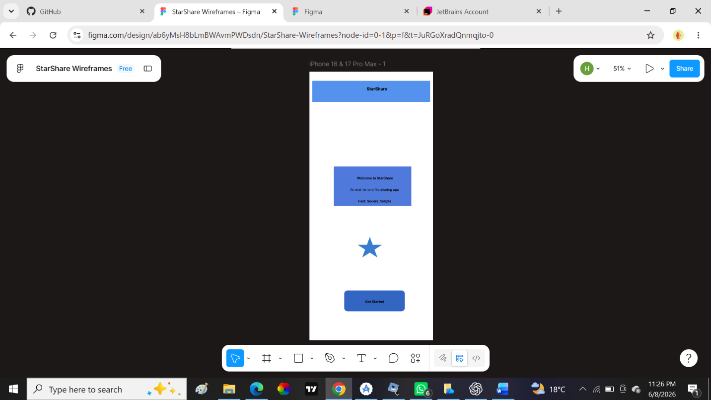
- Figure 2: Splash Screen Wireframe. 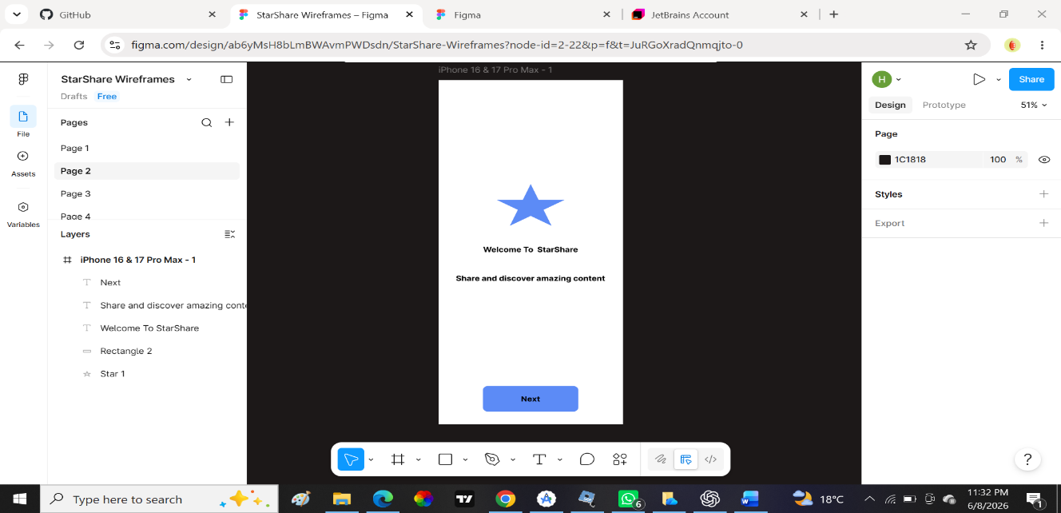

Figure 3: Login screen Wireframe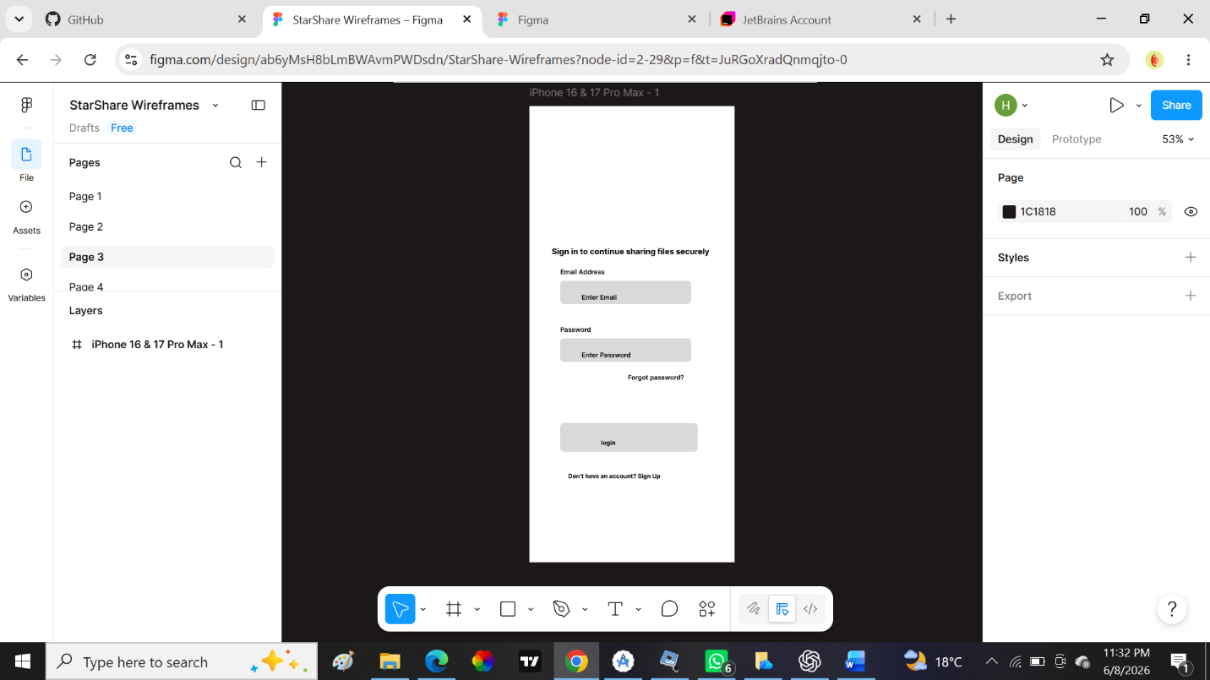
Figure 4: Home Screen Wireframe
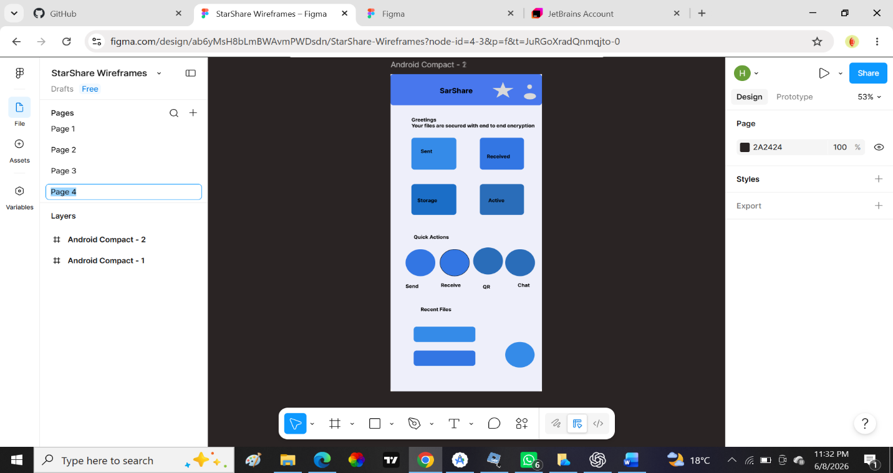
Tools used.
1.Figma
2. Android studio (for references)
Personal Reflection
I developed wireframes using Figma and applied UI/UX design principles to improve usability. This activity provided a visual representation of the application structure and guided future development decisions.

Week 3: User Interface Design
Practical Activities Undertaken
- Refined application wireframes.
- Designed Home Dashboard interface.
- Designed File Upload section
- Designed Storage section
- Improved navigation flow between screens.
- Standardized buttons, icons, and layout structures.
- Reviewed interface consistency and usability.
Figure 1: home screen


Tools/Software Used
- Figma
- Android Studio
- Flutter SDK
Personal Reflection
I refined the user interface design and improved consistency across all screens. The finalized wireframes provided a clear development roadmap and enhanced the overall usability of the StarShare application.

Week 4: Event Handling and User Interaction

Same as week 1

Week 5: Data Management

Same as week 1

Week 6: Networking and APIs

Same as week 1

Week 7: Application Architecture

Same as week 1

Week 8: Project Planning

Week 9: Device Features and Sensors

Same as week 1

Week 10: Notifications and Background Services

Same as week 1

Week 11: Mobile Security

Same as week 1

Week 12: Testing and Debugging

Same as week 1

Week 13: Application Deployment

Same as week 1

Week 14: Final Project Presentation

Same as week 1

Semester Project Tracking

Project Title

Project Objectives

Project Requirements

Development Milestones

Testing Results

Lessons Learned

Future Improvements

End of Semester Reflection

Summary of Skills Acquired

Most Interesting Topic

Major Challenges Faced

How Challenges Were Overcome

Professional Growth Achieved

Overall Course Experience

Final Approval
Student Name: Haron Mutai
Student Signature:
Date: 9th June 2026
Lecturer Name: Michael Nyoro
Lecturer Remarks: _____________________
Date: _________________________________

